BIL/CMP 719 LOCAL FEATURES ASSIGNMENT

Erol Özkan

Department of Computer Engineering, Hacettepe University

erolozkan@outlook.com

***Abstract - Feature detection and matching are an essential component of many computer vision applications. It is used for variety of applications for example aligning the two images so that they can be seamlessly stitched into a composite mosaics or establishing a dense set of correspondences so that a 3D model can be constructed. But selecting the features to compare and match the images is a still ongoing search area. There have been many algorithms implemented for this purpose. In this assignment we try to implement and review some algorithms like HARRIS, MSER, SIFT, PCA-SIFT, GLOH and then we test our algorithms in the symfeat dataset that contains image pairs exhibiting a range of dramatic variations in lighting, age, and rendering style.***

***Keywords:#ComputerVision#KeypointDetection#FeatureExtractionAndMatching***

1. INTRODUCTION

Image matching is a fundamental aspect of many problems in computer vision, including object or scene recognition, solving for 3D structure from multiple images, stereo correspondence, motion tracking and CBIR. A lots of image matching methodologies are proposed at earlier years which some use global features and some use local features. Global ones have difficulty in dealing with partial visibility and extraneous features. In order to handle partial visibility and transformations such as image rotation and scaling, local feature-based features has gain more importance.

The task of image matching based local-features, usually starts with key point discovery and then continues with feature extraction at the interest points. And finally at last step, the features extracted from the two images is being compared. The points are matched based on their similarity values.

Figure 1 shows an example of local feature-based image matching, where the similarity of the two images is to be calculated. Firstly, local features are extracted from both images. Then, these local features are matched in images. In Figure 1, there are three pairs after matching. The most simple way to define the similarity between these two images is to use nearest neighbors assignment between features that has been extracted from two images.

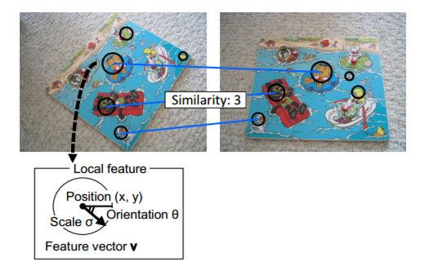

Fig 1. Local Feature-Based Image Matching

To give another example that uses the same idea is to consider a standard CBIR system. In a standard CBIR system, interest points are automatically detected from a single image, and then feature vectors are computed at the interest points. In search step, each of feature vectors extracted from a query image votes scores to matched reference features whose feature vectors are similar to the query feature vector.

In this assignment we try to build a system that can detect key points in images, extract invariant features from them and finally matches features as described above. We first describe and implement three algorithms to detect key points which are HARRIS, MSER and DOG respectively. And then, after finding key points in images; we try to extract discriminative features from our key points. We study and try to implement another three algorithm for this purpose which are SIFT, PCA-SIFT and GLOH. Then, we discuss how feature correspondences can be established across different images and implement a point matching algorithm and an image matching algorithm. Finally, we compare our results with matlab feature detectors. The source codes can be found at the mail that has been sent. The remainder of this paper is structured as follows. Next section describes in details our implemented algorithms. Experimental results, concluding results, remarks and future scope are presented in Section 3 and Section 4 respectively.

II. METHOD

Local features are characterized by the combination of key-point detector and feature extractors around them. First, a key point detector finds feature points/locations, e.g. (x, y), or feature regions, e.g. (x, y, σ), where σ denotes the scale of the region. At this stage, each image is searched for locations that are likely to match well in other images. Then, a feature extractor extracts feature vectors from the detected points or regions to convert each region around detected key point locations into a more compact and stable descriptor that can be matched against other descriptors. This feature detectors and feature descriptors can be used in arbitrary combinations.

*A. Key Point Detection*

In order to match two images, the most important kind of features are the discriminative points such as mountain peaks, building corners, doorways, or interestingly shaped patches of snow. Because, these are noticeably specific locations in images. These kinds of localized features are called key points or corners. They are well suited to be as local features. In this assignment we implement and test 3 key point detectors; Harris, MSER and DOG.

Implementation of HARRIS corner detector:

* The boundary interest points are suppressed using the feature-width:16 pixel.
* The derivatives of the image in the x and y direction are obtained.
* The second moment matrix M, using Ixx, Iyy and Ixy computed.
* This second moment matrix weighted using a gaussian filter.
* The cornerness function computed as det(M) - alpha*trace(M).
* This function is further thresholded to remove unessential interest points.

Implementation of MSER blob detector:

* “bwconncomp” method is used to find connected components in binary image.
* Two object crossing points are extracted as points.
* To be more clear, increment pixel value threshold and see how much new pixels fall into between new threshold value and old threshold value.

Implementation of DOG blob detector:

* Two different gaussian filter has been created and extracted from each other.
* Dog filter is applied to our image.
* Some of the harris methods are used to extract strongest pixel blobs in image.

*B. Feature Extraction*

Now that we have interest points, the following procedure is used to obtain feature vectors around these interest points. We here try to implement a SIFT-LIKE algorithm.

* For each detected interest point, we consider an image patch with dimensions feature_width x feature_width. Here feature_width is 16 pixel.
* For each of the image patch we divide it into windows of 4 x 4 pixels for each.
* In each of these windows we find the dominant gradient for each pixel and place it into the respective bin. There are 8 bins in all each consisting of the number of counts of the gradients falling in a particular range between 0 to 360 degrees, being 45 degree apart.
* So, for each interest point we get a feature vector that contains 128 elements(4*4*8).
* Then we normalized the feature vectors.

*C. Matching And Evaluation*

After obtaining the feature vectors, the next step would be to obtain the features that are similar in both the images.

* We first compute the distance between the features computed in image1 and image2 using pdist2. The distance metric is euclidean.
* Then, we sort the distance matrix.
* From the sorted matrix, we obtain the ratio of the first nearest neighbor to the second nearest neighbor.
* We threshold the value of this ratio.

III. EXPERIMENTATION RESULTS

*A. Creating A Correspondence Template*

First of all, there was a need for comparing results to see how well our implementation detects discriminative key points. So instead of detecting and marking all key points matches manually in both images. We tried to see how matlab’s implementations works. So, we first used matlab’s detectHarrisFeatures and matchFeatures method pair to extract matching points. We observed following results as shown in Fig 2.

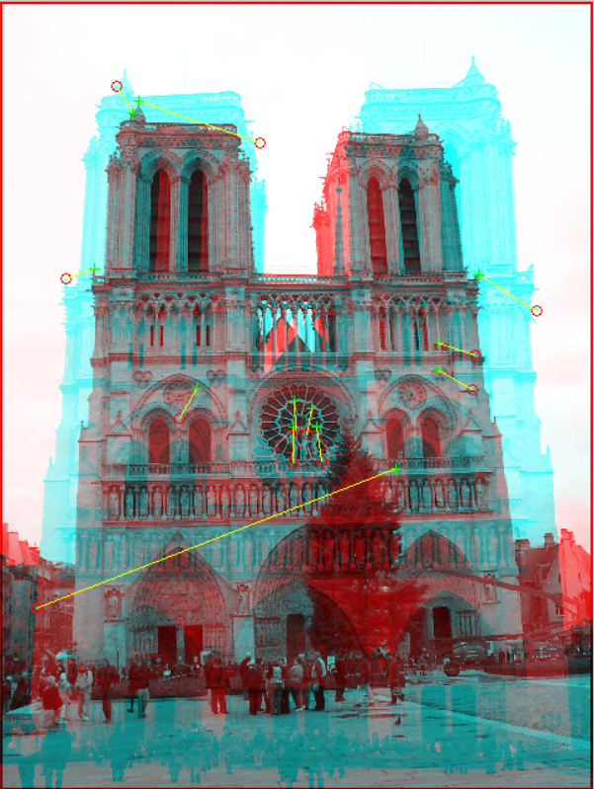

Fig 2. Matlab Harris Method To Match Points

Then we used matlab’s [detectMSERFeatures](https://www.mathworks.com/help/vision/ref/detectmserfeatures.html) and matchFeatures method pair. We observed following results as shown in Fig 3.

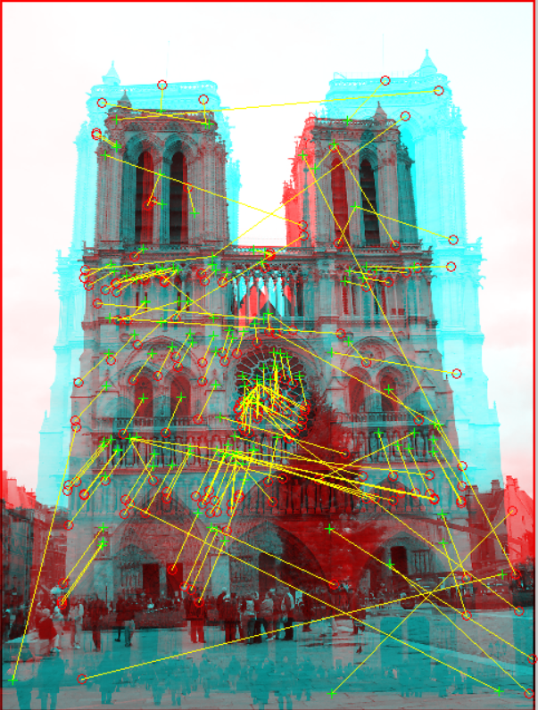

Fig 3. Matlab MSER Method To Match Points

So, we tried to use most of the detector and descriptors in matlab like this. And finally we combined them all. The below two figures represents all of the correspondences between two images that has been extracted with matlab functions as explained. We use this to test the algorithms we implemented.

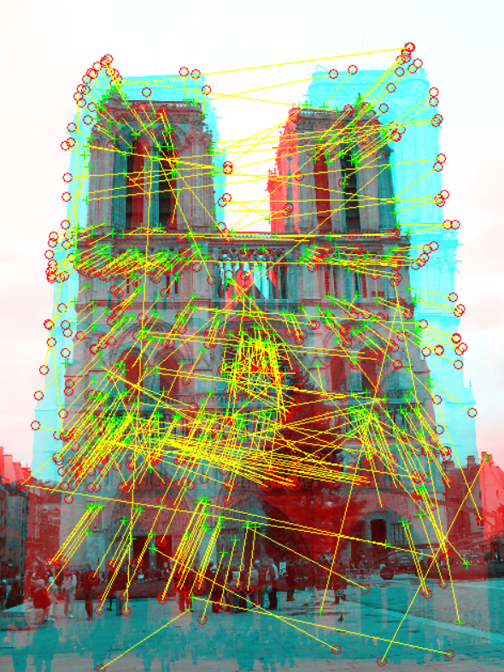

Fig 4. All Correspondences Extracted With Matlab Methods

Below image show different repesentation of all correspondences except those pixel colors equals or very close to clouds’ pixel color. Also, very near key points has been eliminated too. We use this to evaluate our results.

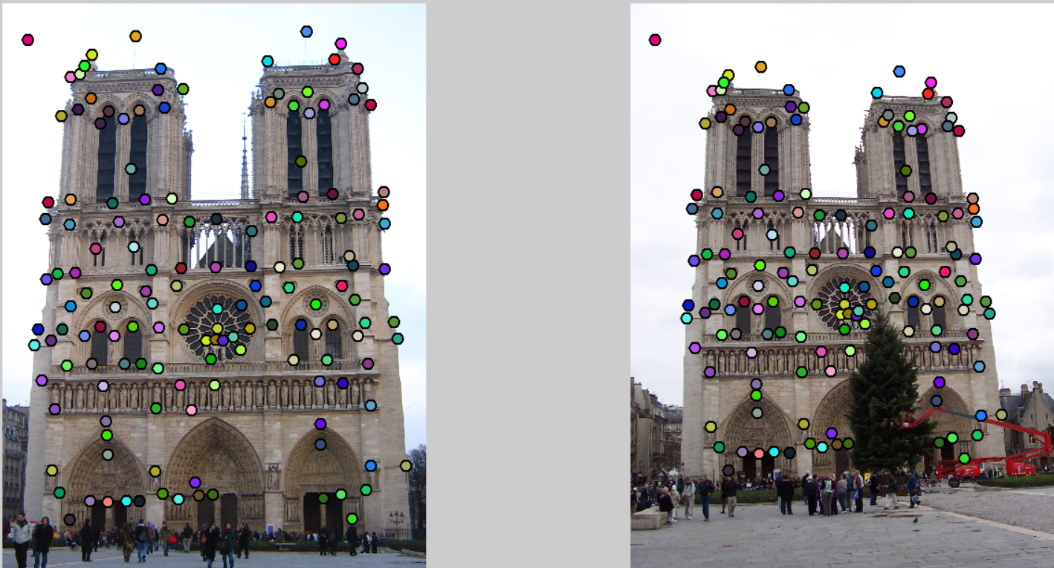

Fig 5. All Correspondences Except Clouds Extracted With Matlab Methods

*B. Key Point Detection*

Below image shows detected key points with harris corner detection algorithm.

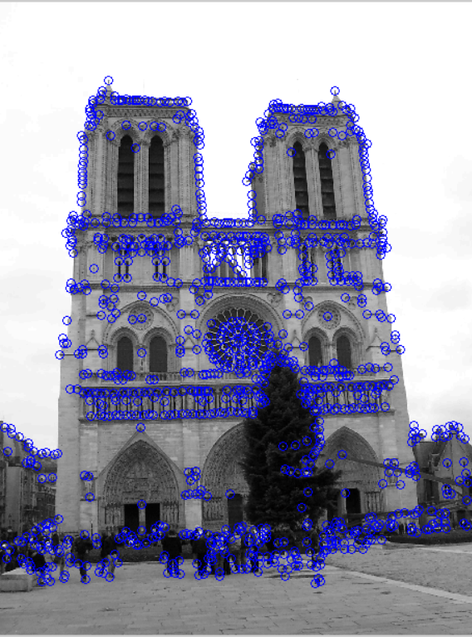

Fig 6. Detected Key Points With Harris

Below image shows detected key points with MSER algorithm.

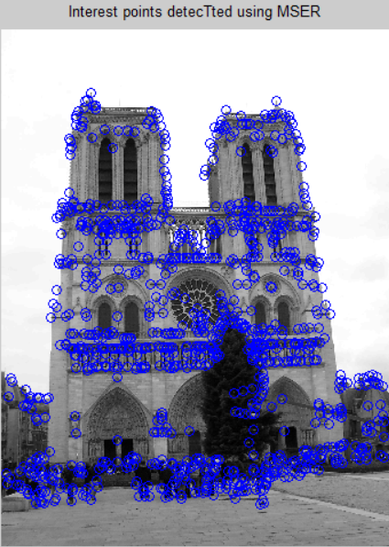

Fig 7. Detected Key Points With MSER

Below image shows detected key points with aplied DOG (difference of gaussian) algorithm.

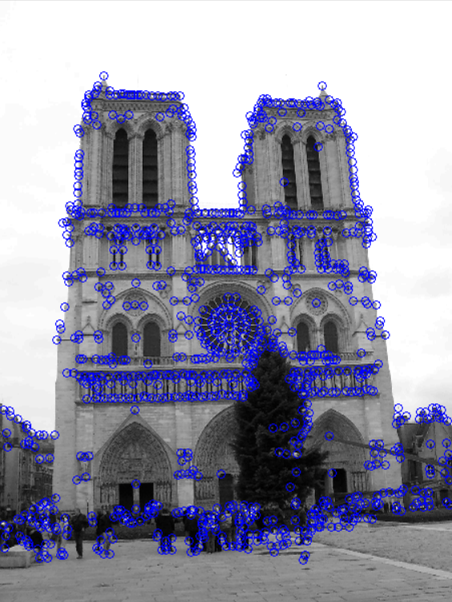

Fig 8. Detected Key Points With DOG blob detector

*C. Matching Stage*

The test with implemented Harris corner detection algorithm shows 32 good matches, 23 bad matches. We calculate if it is a good match or bad match based on two criteria as explained below.

* Checking if correspondence template we prepared at previous step contains the same point with a small 50 pixel error.
* Checking if two correspondence are closer than 25 pixel error.

Table 1 shows the code used for this purpose;

TABLE I

LITTLE CODE SAMPLE FOR LABELING MATCHED INTEREST POINTS

|  |
| --- |
| if(dists(1) > 50 || match_dist > 25)  good_matches(i) = 0;  edgeColor = [1 0 0];  fprintf(' FALSE\n');  else  good_matches(i) = 1;  edgeColor = [0 1 0];  fprintf(' TRUE\n');  end |

Using Harris corner detection algorithm, the interest points or key points has been matched between two images are represented in Fig 9. Fig 10 shows also whether this matches are correct or incorrect.

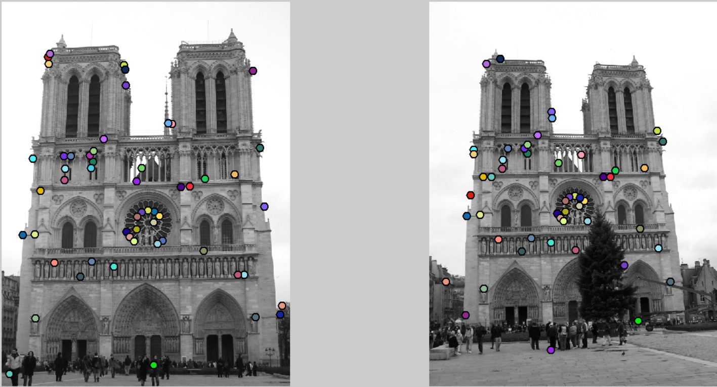

Fig 9. Matched Interest Points Between Two Images With Harris Corner Detection

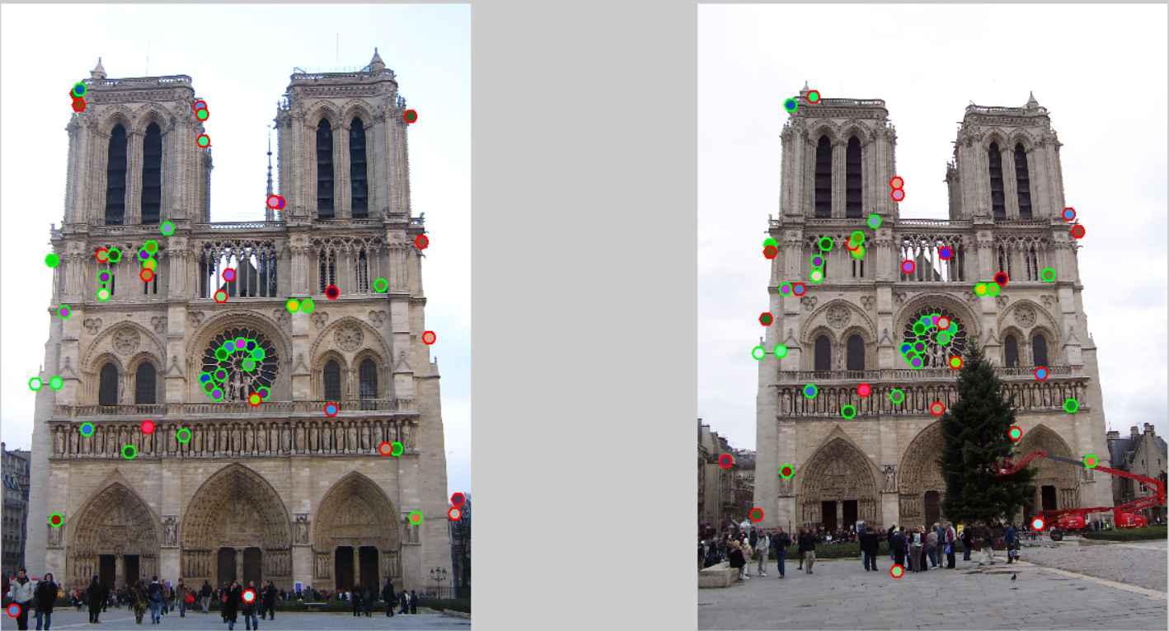

Fig 10. Labeled Matched Interest Points Between Two Images

The interest points or key points has been matched between two images is as shown in TABLE II. “INDEX” column represents the index of that key point in first image, “ERROR” column represents the distance between two key points. And last label is TRUE or FALSE based on if these two key points has been labeled as correct or incorrect.

TABLE II

MATCHED INTEREST POINTS WITH GIVEN ERROR AND LABEL

|  |
| --- |
| ( 488, 852) to ( 520, 804) INDEX: 34 ERROR: 4 TRUE  ( 810, 1178) to ( 796, 1082) INDEX: 28 ERROR: 4 TRUE  ( 668, 1226) to ( 678, 1120) INDEX: 46 ERROR: 9 TRUE  ( 168, 838) to ( 236, 784) INDEX: 55 ERROR: 12 TRUE  ( 478, 888) to ( 390, 836) INDEX: 3 ERROR: 121 FALSE  ( 340, 892) to ( 390, 836) INDEX: 3 ERROR: 3 TRUE  ( 182, 1688) to ( 290, 1518) INDEX: 5 ERROR: 2 TRUE  ( 816, 1120) to ( 798, 1036) INDEX: 36 ERROR: 8 TRUE  ( 1400, 1092) to ( 648, 582) INDEX: 68 ERROR: 742 FALSE  ( 782, 1112) to ( 770, 1028) INDEX: 3 ERROR: 2 TRUE  ( 1292, 1456) to ( 1212, 1304) INDEX: 42 ERROR: 1 TRUE  ( 470, 820) to ( 504, 778) INDEX: 54 ERROR: 4 TRUE  ( 116, 1244) to ( 200, 1134) INDEX: 3 ERROR: 4 TRUE  ( 254, 332) to ( 238, 806) INDEX: 56 ERROR: 455 FALSE  ( 544, 734) to ( 574, 706) INDEX: 34 ERROR: 18 TRUE  ( 842, 1144) to ( 822, 1054) INDEX: 55 ERROR: 17 TRUE  ( 662, 448) to ( 1030, 1394) INDEX: 101 ERROR: 974 FALSE  ( 180, 1240) to ( 270, 1128) INDEX: 16 ERROR: 3 TRUE  ( 720, 958) to ( 646, 1840) INDEX: 55 ERROR: 941 FALSE  ( 332, 824) to ( 504, 778) INDEX: 66 ERROR: 124 FALSE  ( 654, 340) to ( 1204, 682) INDEX: 30 ERROR: 645 FALSE  ( 720, 1214) to ( 720, 1112) INDEX: 22 ERROR: 17 TRUE  ( 748, 1122) to ( 742, 1034) INDEX: 36 ERROR: 5 TRUE  ( 598, 1412) to ( 646, 1274) INDEX: 55 ERROR: 10 TRUE  ( 370, 824) to ( 418, 778) INDEX: 61 ERROR: 14 TRUE  ( 684, 1254) to ( 694, 1144) INDEX: 65 ERROR: 10 TRUE  ( 858, 1274) to ( 838, 1162) INDEX: 18 ERROR: 7 TRUE  ( 210, 1008) to ( 286, 928) INDEX: 29 ERROR: 4 TRUE  ( 722, 1146) to ( 720, 1054) INDEX: 68 ERROR: 9 TRUE  ( 1082, 944) to ( 986, 894) INDEX: 8 ERROR: 29 FALSE  ( 420, 1466) to ( 492, 1322) INDEX: 66 ERROR: 5 TRUE  ( 1078, 1328) to ( 1116, 1200) INDEX: 40 ERROR: 94 FALSE  ( 480, 1384) to ( 542, 1252) INDEX: 82 ERROR: 26 FALSE  ( 1240, 920) to ( 1138, 880) INDEX: 18 ERROR: 2 TRUE  ( 250, 296) to ( 222, 1024) INDEX: 29 ERROR: 684 FALSE  ( 660, 362) to ( 376, 304) INDEX: 52 ERROR: 280 FALSE  ( 956, 988) to ( 922, 926) INDEX: 54 ERROR: 2 TRUE  ( 1484, 1668) to ( 798, 1036) INDEX: 22 ERROR: 708 FALSE  ( 706, 1276) to ( 712, 1162) INDEX: 52 ERROR: 11 TRUE  ( 284, 1390) to ( 368, 1258) INDEX: 81 ERROR: 12 TRUE  ( 1354, 1680) to ( 1274, 1482) INDEX: 18 ERROR: 8 TRUE  ( 812, 1936) to ( 1104, 1688) INDEX: 161 ERROR: 278 FALSE  ( 748, 886) to ( 684, 852) INDEX: 75 ERROR: 57 FALSE  ( 830, 1292) to ( 838, 1162) INDEX: 49 ERROR: 38 FALSE  ( 1002, 986) to ( 958, 926) INDEX: 28 ERROR: 2 TRUE  ( 1494, 1620) to ( 92, 1482) INDEX: 64 ERROR: 1276 FALSE  ( 490, 796) to ( 520, 758) INDEX: 67 ERROR: 6 TRUE  ( 1376, 778) to ( 1234, 740) INDEX: 23 ERROR: 27 FALSE  ( 908, 652) to ( 804, 810) INDEX: 140 ERROR: 185 FALSE  ( 338, 952) to ( 388, 884) INDEX: 63 ERROR: 9 TRUE  ( 1338, 370) to ( 194, 1658) INDEX: 4 ERROR: 1555 FALSE  ( 258, 280) to ( 304, 328) INDEX: 16 ERROR: 4 TRUE  ( 1258, 1454) to ( 776, 1314) INDEX: 76 ERROR: 401 FALSE  ( 44, 1982) to ( 332, 928) INDEX: 229 ERROR: 879 FALSE  ( 890, 648) to ( 650, 618) INDEX: 153 ERROR: 196 FALSE |

Using MSER blob detection algorithm, the interest points or key points has been matched between two images are represented in Fig 11. Fig 12 shows also whether this matches are correct or incorrect. MSER detects 21 good matches, 6 bad matches.

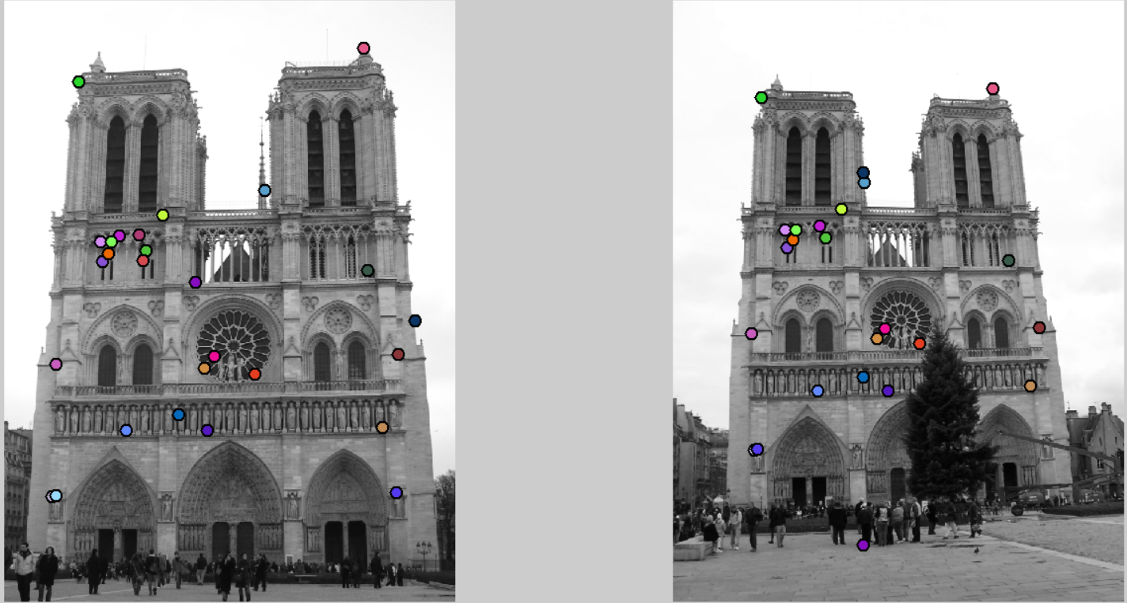

Fig 11. Matched Interest Points Between Two Images With MSER

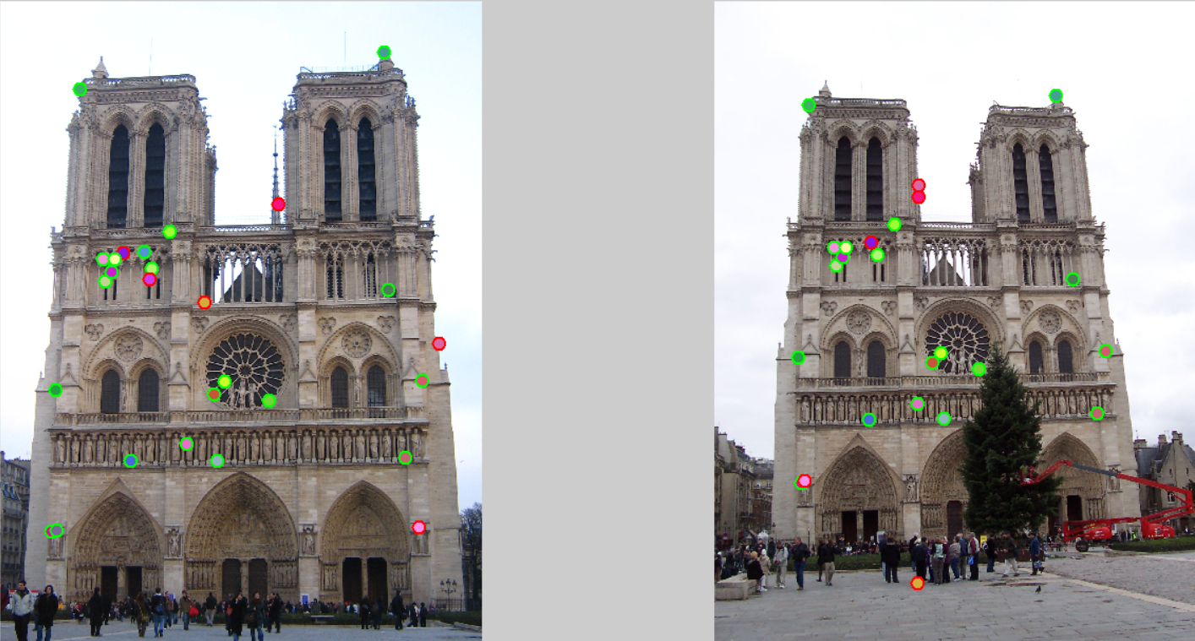

Fig 12. Labeled Matched Interest Points Between Two Images

The interest points or key points has been matched between two images is as shown in TABLE III. “INDEX” column represents the index of that key point in first image, “ERROR” column represents the distance between two key points. And last label is TRUE or FALSE based on if these two key points has been labeled as correct or incorrect.

TABLE III

MATCHED INTEREST POINTS WITH GIVEN ERROR AND LABEL

|  |
| --- |
| ( 486, 852) to ( 518, 804) INDEX: 34 ERROR: 4 TRUE  ( 164, 1692) to ( 276, 1522) INDEX: 17 ERROR: 3 TRUE  ( 476, 888) to ( 388, 836) INDEX: 4 ERROR: 121 FALSE  ( 338, 892) to ( 388, 836) INDEX: 3 ERROR: 3 TRUE  ( 682, 1254) to ( 692, 1144) INDEX: 67 ERROR: 10 TRUE  ( 462, 800) to ( 498, 762) INDEX: 40 ERROR: 1 TRUE  ( 418, 1466) to ( 490, 1322) INDEX: 65 ERROR: 5 TRUE  ( 542, 734) to ( 572, 706) INDEX: 32 ERROR: 18 TRUE  ( 654, 960) to ( 644, 1840) INDEX: 4 ERROR: 942 FALSE  ( 180, 1688) to ( 288, 1518) INDEX: 5 ERROR: 2 TRUE  ( 358, 862) to ( 406, 810) INDEX: 33 ERROR: 7 TRUE  ( 1344, 1208) to ( 1238, 1108) INDEX: 56 ERROR: 9 TRUE  ( 692, 1466) to ( 728, 1320) INDEX: 11 ERROR: 6 TRUE  ( 1290, 1456) to ( 1210, 1304) INDEX: 44 ERROR: 1 TRUE  ( 330, 824) to ( 382, 778) INDEX: 66 ERROR: 13 TRUE  ( 1224, 164) to ( 1080, 300) INDEX: 19 ERROR: 4 TRUE  ( 888, 648) to ( 648, 618) INDEX: 154 ERROR: 196 FALSE  ( 394, 804) to ( 498, 762) INDEX: 31 ERROR: 68 FALSE  ( 596, 1412) to ( 644, 1274) INDEX: 56 ERROR: 10 TRUE  ( 178, 1240) to ( 268, 1128) INDEX: 16 ERROR: 3 TRUE  ( 856, 1274) to ( 836, 1162) INDEX: 19 ERROR: 7 TRUE  ( 1238, 920) to ( 1136, 880) INDEX: 20 ERROR: 2 TRUE  ( 718, 1214) to ( 718, 1112) INDEX: 24 ERROR: 17 TRUE  ( 256, 280) to ( 302, 328) INDEX: 15 ERROR: 4 TRUE  ( 368, 824) to ( 416, 778) INDEX: 63 ERROR: 14 TRUE  ( 1398, 1092) to ( 646, 582) INDEX: 69 ERROR: 742 FALSE  ( 1336, 1678) to ( 288, 1518) INDEX: 2 ERROR: 974 FALSE |

Using DOG blob detection algorithm, the interest points or key points has been matched between two images are represented in Fig 13. Fig 14 shows also whether this matches are correct or incorrect. DOG detects 18 good matches, 4 bad matches.

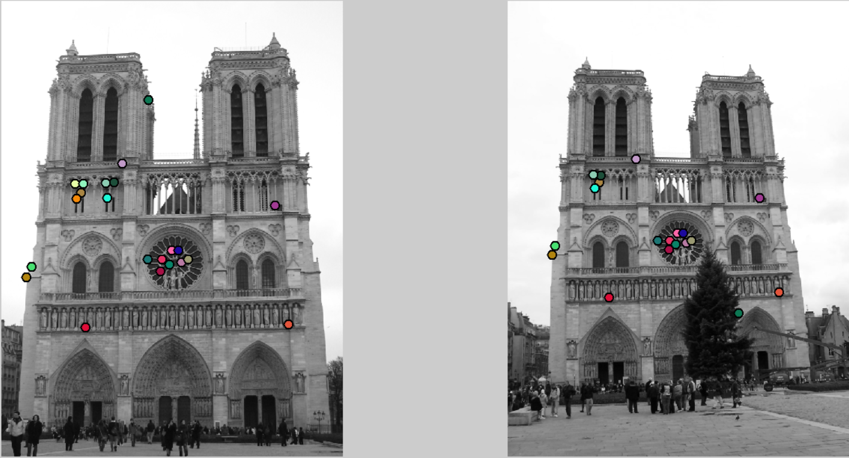

Fig 13. Matched Interest Points Between Two Images With DOG

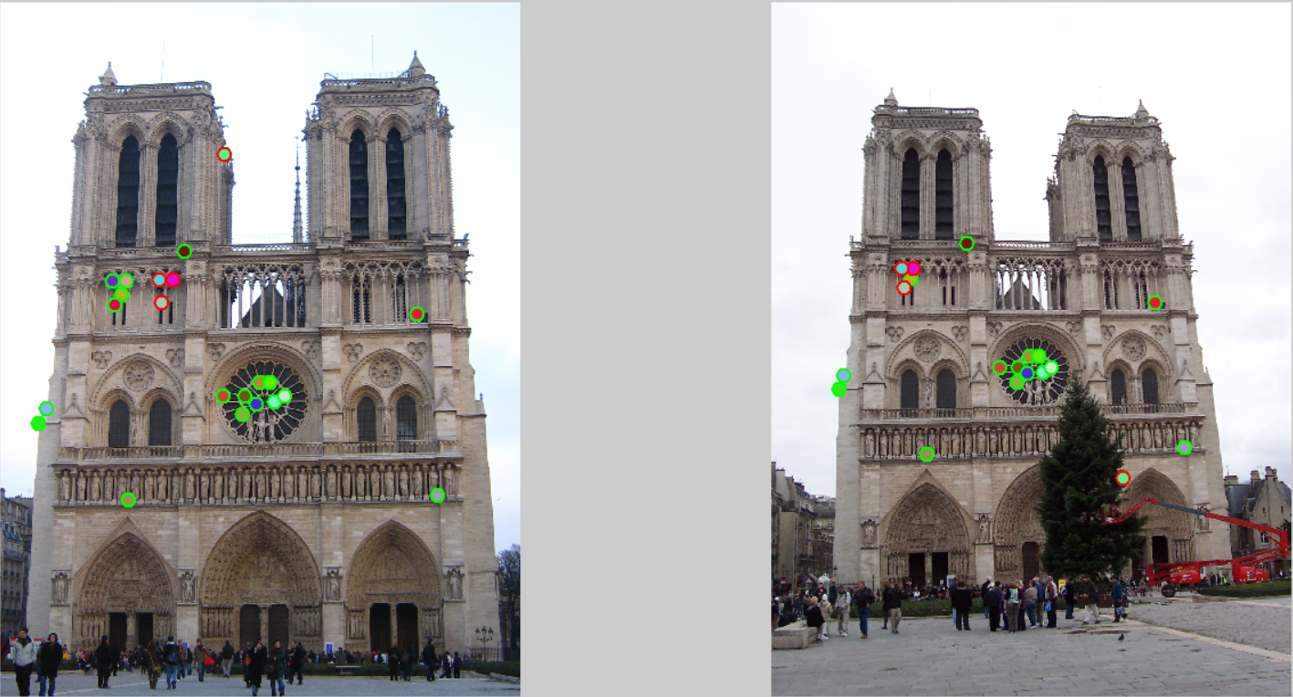

Fig 14. Labeled Matched Interest Points Between Two Images

The interest points or key points has been matched between two images is as shown in TABLE II. “INDEX” column represents the index of that key point in first image, “ERROR” column represents the distance between two key points. And last label is TRUE or FALSE based on if these two key points has been labeled as correct or incorrect.

TABLE IV

MATCHED INTEREST POINTS WITH GIVEN ERROR AND LABEL

|  |
| --- |
| ( 810, 1178) to ( 798, 1082) INDEX: 28 ERROR: 3 TRUE  ( 724, 1164) to ( 724, 1070) INDEX: 60 ERROR: 10 TRUE  ( 766, 1122) to ( 758, 1036) INDEX: 20 ERROR: 2 TRUE  ( 332, 824) to ( 384, 778) INDEX: 66 ERROR: 13 TRUE  ( 798, 1122) to ( 784, 1036) INDEX: 21 ERROR: 5 TRUE  ( 372, 824) to ( 418, 780) INDEX: 59 ERROR: 11 TRUE  ( 360, 862) to ( 410, 810) INDEX: 34 ERROR: 7 TRUE  ( 340, 892) to ( 390, 836) INDEX: 3 ERROR: 3 TRUE  ( 116, 1244) to ( 200, 1134) INDEX: 3 ERROR: 4 TRUE  ( 1292, 1454) to ( 1212, 1302) INDEX: 43 ERROR: 1 TRUE  ( 510, 818) to ( 418, 780) INDEX: 74 ERROR: 126 FALSE  ( 716, 1216) to ( 720, 1112) INDEX: 26 ERROR: 13 TRUE  ( 138, 1198) to ( 214, 1094) INDEX: 16 ERROR: 8 TRUE  ( 544, 734) to ( 574, 706) INDEX: 34 ERROR: 18 TRUE  ( 478, 888) to ( 390, 836) INDEX: 3 ERROR: 121 FALSE  ( 662, 448) to ( 1030, 1394) INDEX: 101 ERROR: 974 FALSE  ( 1230, 920) to ( 1124, 880) INDEX: 28 ERROR: 2 TRUE  ( 840, 1162) to ( 820, 1070) INDEX: 48 ERROR: 11 TRUE  ( 756, 1186) to ( 750, 1088) INDEX: 27 ERROR: 4 TRUE  ( 660, 1164) to ( 670, 1070) INDEX: 17 ERROR: 3 TRUE  ( 470, 820) to ( 384, 778) INDEX: 54 ERROR: 122 FALSE  ( 380, 1468) to ( 456, 1324) INDEX: 48 ERROR: 2 TRUE |

IV. CONCLUSION AND FUTURE SCOPE

Local features are indeed an essential component of many computer vision applications. They are used for variety of applications. Furthermore, the type of local features that give fine results changes from image to image where all images exhibits different variations in lighting, age, and rendering style. That’s why many algorithms have been implemented for detecting interest points and extracting features from them.

In this assignment we tried to build a system can detect interest or key points in images, extract invariant features from them and finally match them based on their euclidean distance. We implemented three algorithms for key point detection; HARRIS, MSER and DOG respectively. And then, after finding key points in images; we tried to implement another there algorithms to extract invariant features from them; SIFT, PCA-SIFT and GLOH. There is also a match point and a match image implementations. Furthermore, we compare our algorithms with matched points that matlab functions has found.

REFERENCES

[1] David G. Lowe, “Distinctive Image Features from Scale-Invariant Key points”, 2004

[2] A. Baumberg. Reliable feature matching across widely separated views. In CVPR00, pages I:774–781, 2000.

[3] Y. Dufournaud, C. Schmid, and R. Horaud. Matching images with different resolutions. In CVPR00, pages I:612–618, 2000.

[4] W. Eric L. Grimson. Object Recognition. MIT Press, 1990.

[5] R. Hartley. In defence of the 8-point algorithm. In ICCV95, pages 1064–1070, 1995.

[6] R. Hartley and A. Zisserman. Multiple View Geometry in Computer Vision. Cambridge University Press, Cambridge, UK, 2000.

[7] Gonzalez, R. C., Woods, R.E., Digital Image Processing, Addison Wesley, 1992. (New Jersey: Prentice-Hall).

[8] Aparna K G, Ramakrishnan A G, 2002 A complete Tamil Optical Character Recognition System. 5th International Workshop on Document Analysis Systems DAS 2002, Princeton, NJ, USA, pp. 53-57.

[9] Ronsen, C., Denijver, P.A., "Connected components in Binary Images: The Detection Problem", Research Studies Press, 1984.